Customer targeted E-commerce: INSURANCE CORNER

BCSE203E - WEB PROGRAMMING

PROJECT DOCUMENT

Winter Semester 2025 – 2026

24BCE0149

UNDER THE GUIDENCE OF
Dr. KAUSER AHMED P
SCOPE
Section | Main Heading | Contents
1 | Abstract | One-page summary of the project
2 | Introduction | Aim & Objective
3 | System Requirements | Software requirements
4 | Recent Technology Adapted | Technology:  1. Technology-1 description  2. Sample code & Screenshot
5 | Solution for Existing Problems | Solution  1. Problem description and its Solution  2. Sample code & Screenshot  Solution-2  1. Problem description and its Solution  2. Sample code & Screenshot
6 | Screenshots | Selected frontend design
7 | Implementation Code | Core source code scripts
8 | Conclusion | Final summary and project wrap-up

- ABSTRACT

The insurance industry has been keep relying on slow, manual quoting, calculation workflows that nowadays clash with modern expectations like self-service and instant experiences. Customers face the Quotations, return, eligibility waiting gaps, biased opinions, submitting forms, then waiting hours or days for an agent to return with a premium. But at the same time, websites on the other hand allows visitors with generic, one-size-fits-all policy listings, leading to Information overload and decision paralysis than direct purchase decisions.

This project focuses on these main points by making a customer-targeted e-commerce platform for our own insurance agency/ startup, entirely with responsive HTML, CSS, and JavaScript. The application operates as an intelligent digital storefront, shifting premium calculation from back-office systems to the client side. When users enter their age, policy type, and desired coverage, JavaScript then can perform the company-based actual calculations in the browser, which gives customer a real-time price transparency without any bias and helping user to get all companies’ data/info. in 1 go. To eliminate choice overload, the platform incorporates algorithmic/(filters) using JavaScript by an automated digital agent that instantly hides irrelevant plans and dynamically updates the list of plans for individual customer, showing only those policies that match the user’s profile and eligibility and interest.

- INTRODUCTION

Customers who want insurance coverage face two equally heavy problems. On one hand, the traditional route requires customers to submit personal details through legal forms and wait hours—or even days—for a human agent to calculate and return with premium quotations. This creates an "eligibility waiting gap" and also makes the buyer bend to biased opinions. Agents may intentionally push policies that benefit the agency than the consumer. On the other hand, the existing online alternatives often fail to provide a helpful experience. Most conventional insurance websites present visitors with generic, one-size-fits-all policy catalogs. Instead of facilitating a smooth, direct purchase, this "data dumping" approach makes the user, leading directly to information overload and decision making problems.
Gap between modern consumer expectations and outdated industry practices, this project introduces a specialized, customer-targeted e-commerce platform developed for our independent startup, Insurance Corner. The fundamental behind Insurance Corner is to maximize user convenience by returning the power of choice directly to the consumer. Designed as an responsive digital store, this project is built using a frontend stack: HTML, CSS, and JavaScript.
We avoid slow backend server requests and shifting the computational workload to the client side. When a user interacts with the application—inputting simple data as their age, desired policy type, and required coverage amount—the JavaScript engine instantly performs, company-based premium calculations directly within the browser. This guarantees zero-latency responsiveness,which offers customers real-time price transparent answers without biased sales tactics.

To reduce this problem of choice overload, Insurance Corner employs algorithmic filtering. An automated digital agent built into the JavaScript logic evaluates the user’s profile against the available policies. It instantly rejects irrelevant plans and dynamically updates the UI, targeted list of policies. By presenting the data that matches the user’s specific profile and, the platform makes the customer to make confident, unbiased, and direct purchase decisions.

Aim & Objective

Develop a highly easy to help ourself, client-side e-commerce web application for Insurance Corner that helps users to independently explore, calculate, and select highly targeted insurance policies in a transparent, real-time, and completely unbiased digital way.

Objectives:

Develop a Responsive Digital frontend: To make accessible user interface using modern HTML5 and CSS3, ensuring a smooth experience in all devices without relying on backend.

Implement Real-Time Premium Calculations: To use JavaScript to execute instant, in-browser premium calculations based on user input, entirely removing the traditional waiting periods with manual agent quoting.

Remove Information Overload: Create automated algorithmic filtering system using JavaScript array methods that dynamically edit the displayed policy to the individual user’s financial eligibility.

Non-Biased Decision Making: all company data is presented transparently and instantly, by which the customer act as their own agent and make informed choices without external pressure.

- SYSTEM REQUIREMENTS

Insurance Corner is made as a modern, client-side web application, it removed the need for backend server. The system requirements are lightweight and focused entirely on the frontend development and execution flow.

Development Environment:
- Core Technologies: HTML5, CSS3, and modern JavaScript.
- Code Editor: Visual Studio Code
- Version Control: Git

Execution Environment (Client-Side):
- Web Browsers: A standard web browser is needed to process the JavaScript calculations and handle local storage. Recommended browsers like chrome ,safari.
- Hardware: Any basic laptop, or smartphone with a modern web browser. No specialized computational hardware is required as the algorithms are highly optimized.

4) RECENT TECHNOLOGY ADAPTED

Technology: HTML5 Web Storage & Advanced Client-Side JavaScript Algorithms

To Deliver a highly targeted, zero-latency experience, Insurance Corner uses :
Client-Side JavaScript Array method combined with the HTML5.
E-commerce platforms depend on external servers to process user data and filter products, which causes loading delays and privacy concerns. By modern frontend, our platform processes everything directly in the browser. When a customer inputs their details (such as age, desired coverage, or BMI metrics), the HTML5 Web Storage API temporarily holds this data during the session.
Simultaneously, the JavaScript engine utilizes advanced array algorithms to cross-reference the user's profile against our insurance policies. This technology acts as unbiased digital filter, it instantly hides ineligible plans and shows only the exact policies the customer qualifies for. By shifting the entire computational workload to the client’s device, the application keeps maximum privacy, UI updates, and smooth , self-service experience without depending on any external store.

The Technology Workflow:
- Data Capture: The user enters their need (e.g., Age: 24, Type: Health) into the HTML form.
- Instant Intercept: JavaScript instantly takes this input preventing any page reload.
- Algorithmic Filtering: The built-in JavaScript engine rapidly filters the complete list of policies, keeping away any plans that do not match the user's age bracket or category preference.
- Dynamic Rendering: The browser's Document Object Model (DOM) is instantly updated to display the curated, targeted policy cards along with their dynamically calculated premium prices.

5) SOLUTION FOR EXISTING PROBLEMS

Solution-1: Eradicating Manual Quoting Delays and the "Eligibility Waiting Gap"

The Insurance Corner website solves this latency issue by removing the human work from the quoting process. By putting the computational of modern web browsers, the platform moves the entire premium calculation to the client side. We designed interactive, real-time tools—such as the BMI Calculator and the Quotation Finder—that respond instantaneously to user input.
Instead of submitting a form to a server and waiting, the user simply can edit their values (like age, policy type, and coverage amount) directly on the web page. The system instantly processes these inputs using formulas in the JavaScript logic, generating accurate, company-specific premium prices. This transforms a multi-day waiting game into real-time interaction. By providing immediate price transparency without page reloads, the platform helps users to easily try with different coverage tiers and make financial decisions strictly on their own.

Logics used:
Event Listening: The HTML form elements (dropdowns, number inputs) are equipped with JavaScript event detector for user interactions in real time.
Instant Value Capture: The time an input changes, the JavaScript intercepts the new value and prevents any submission previous.
Client-Side calc.: The script applies company-specific rate for user's input to calculate the exact annual premium.
Live DOM Update: The calculation is instantly sent back into the Document Object Model, updating the price displayed on the user's screen in a fraction of a second, ensuring self-service experience.

Solution-2: Removing Data Overload and Agent Bias

To cover both decision problem and biased sell issue, Insurance Corner is an automated, bias-free "Digital Advisor" driven entirely by client-side algorithmic filtering. The core idea of this solution is not to show a customer a policy that is not proper for their specific profile.
When a user puts inputs in the platform, they are asked for a few simple parameters. The platform’s JavaScript logic then acts as an immediate. It compares the user's data to our complete internal criteria of policies. Plans that do not match the user's age gap or requested category are hidden from the user interface. What remains is a highly filterd data output, list of targeted policy recommendations. By filtering visual interface and presenting only valid, unbiased options, the platform removes choice overload. The customer is treated as agent, navigating transparent digital webpage for their needs.

Logics used:
Profile Generation: The user submits their basic details (Age 24, Auto Insurance) in the frontend interface.
Algorithmic Filtering: The JavaScript engine use modern array iteration methods to scan through the digital way of available insurance plans. It computes the minimum and maximum age eligibility parameters of every policy against the user's inputted age.
Exclusion: Any policy that fails the eligibility check is completely removed from the active dataset, so that the user will not see incompatible products.
Targeted UI updatn: The final list of eligible policies is dynamically mapped into HTML creating a clean, personalized options for that individual user.

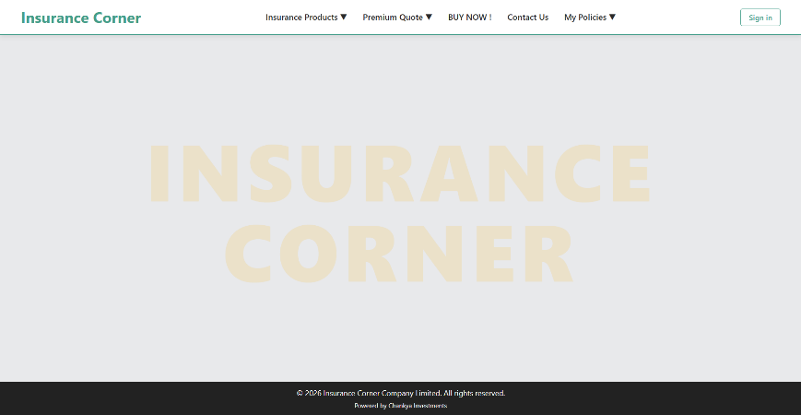
6) SCREENSHOTS FROM WEBSITE
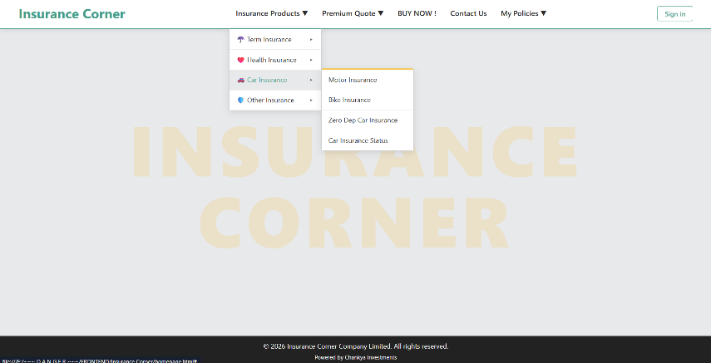

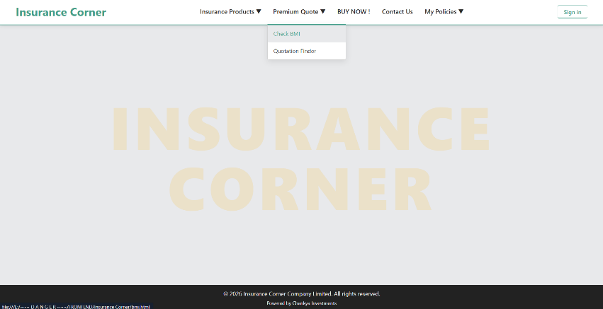
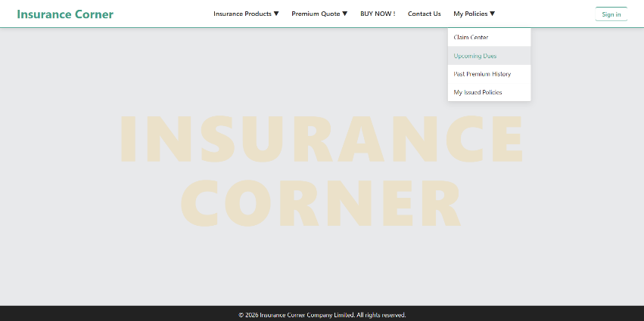

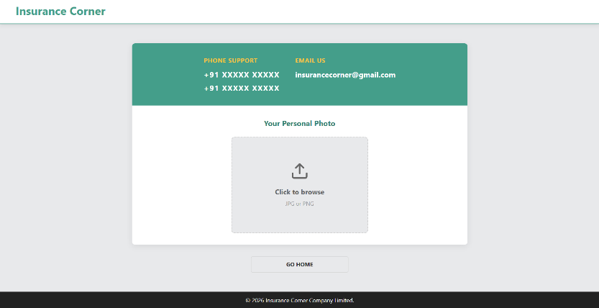
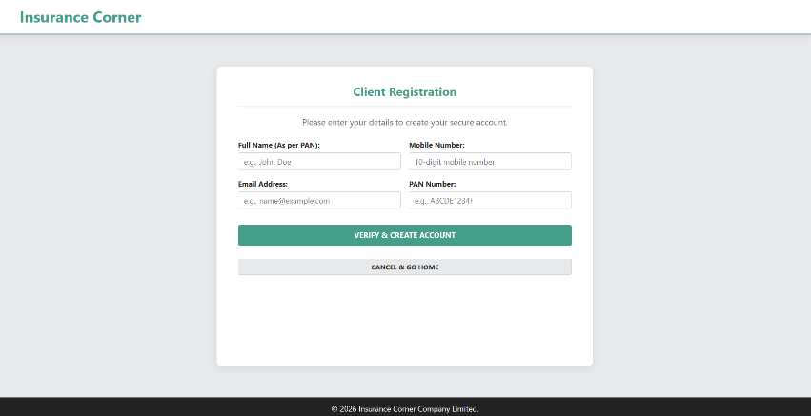

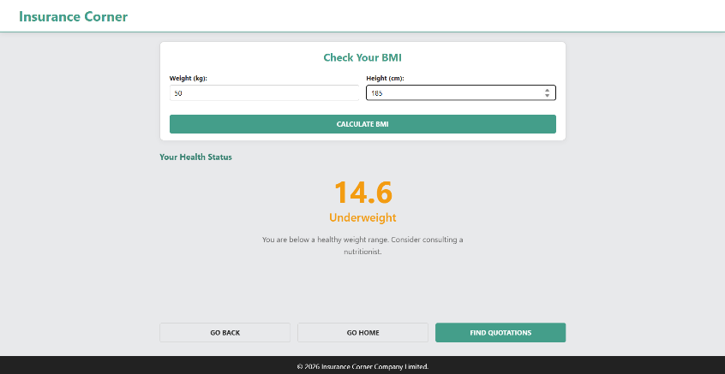
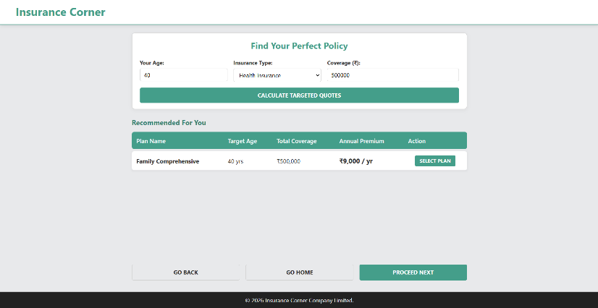

7) CODE
HOMEPAGE.HTML
<!DOCTYPE html>
<html lang="en">
<head>
<meta charset="UTF-8">
<meta name="viewport" content="width=device-width, initial-scale=1.0">
<title>Insurance Corner | Compare & Buy</title>
<link rel="stylesheet" href="style.css">
</head>
<body>

<nav class="navbar">
<div class="nav-container">
<a href="homepage.html" class="logo">Insurance Corner</a>

<ul class="nav-links">
<li class="dropdown">
<a href="#">Insurance Products <span>▼</span></a>
<ul class="drop-nav">
<li class="flyout">
<a href="#">☂️ Term Insurance</a>
<ul class="flyout-nav">
<li><a href="#">Life Insurance</a></li>
<li><a href="#">Best Term Plan</a></li>
<li><a href="#">Term Plan Calculator</a></li>
<li><a href="#">1 Crore Term Insurance</a></li>
</ul>
</li>
<li class="flyout">
<a href="#">❤️ Health Insurance</a>
<ul class="flyout-nav">
<li><a href="#">Family Health Insurance</a></li>
<li><a href="#">Senior Citizen Health</a></li>
<li><a href="#">Maternity Insurance</a></li>
<li><a href="#">Health Calculator</a></li>
</ul>
</li>
<li class="flyout">
<a href="#">🚗 Car Insurance</a>
<ul class="flyout-nav">
<li><a href="#">Motor Insurance</a></li>
<li><a href="#">Bike Insurance</a></li>
<li><a href="#">Zero Dep Car Insurance</a></li>
<li><a href="#">Car Insurance Status</a></li>
</ul>
</li>
<li class="flyout">
<a href="#">🛡️ Other Insurance</a>
<ul class="flyout-nav">
<li><a href="#">Travel Insurance</a></li>
<li><a href="#">Group Health Insurance</a></li>
<li><a href="#">Marine Insurance</a></li>
<li><a href="#">Professional Indemnity</a></li>
</ul>
</li>
</ul>
</li>

<li class="dropdown">
<a href="#">Premium Quote <span>▼</span></a>
<ul class="drop-nav">
<li><a href="bmi.html">Check BMI</a></li>
<li><a href="quotes.html">Quotation Finder</a></li>
</ul>
</li>
<li><a href="#">BUY NOW !</a></li>
<li><a href="contactus.html">Contact Us</a></li>
<li class="dropdown">
<a href="#">My Policies <span>▼</span></a>
<ul class="drop-nav">
<li><a href="#">Claim Center</a></li>
<li><a href="#">Upcoming Dues</a></li>
<li><a href="#">Past Premium History</a></li>
<li><a href="#">My Issued Policies</a></li>
</ul>
</li>
</ul>

<div class="nav-actions">
<a href="signup.html" class="btn-outline">Sign in</a>
</div>
</div>
</nav>

<main class="faded-background">
<div class="faded-text">Insurance<br>Corner</div>
</main>

<footer>
<p>&copy; 2026 Insurance Corner Company Limited. All rights reserved.</p>
<p><small>Powered by Chankya Investments</small></p>
</footer>

</body>
</html>

SIGNUP.HTML
<!DOCTYPE html>
<html lang="en">
<head>
<meta charset="UTF-8">
<meta name="viewport" content="width=device-width, initial-scale=1.0">
<title>Sign Up | Insurance Corner</title>
<link rel="stylesheet" href="style.css">
</head>
<body>

<nav class="navbar">
<div class="nav-container minimal">
<a href="homepage.html" class="logo">Insurance Corner</a>
</div>
</nav>

<div class="container registration-container">
<div class="card registration-card">
<h2 class="form-title">Client Registration</h2>
<p class="text-center" style="margin-bottom: 20px; color: var(--text-muted);">Please enter your details to create your secure account.</p>

<form id="signupForm" class="registration-form" novalidate>

<div class="form-row-2">
<div class="form-group">
<label for="fullName" class="form-label">Full Name (As per PAN):</label>
<input type="text" id="fullName" class="form-input" placeholder="e.g., John Doe" required>
<span class="error-message" id="nameError">Please enter a valid name (letters only).</span>
</div>

<div class="form-group">
<label for="phoneNum" class="form-label">Mobile Number:</label>
<input type="tel" id="phoneNum" class="form-input" placeholder="10-digit mobile number" required>
<span class="error-message" id="phoneError">Please enter a valid 10-digit mobile number.</span>
</div>
</div>

<div class="form-row-2">
<div class="form-group">
<label for="emailId" class="form-label">Email Address:</label>
<input type="email" id="emailId" class="form-input" placeholder="e.g., name@example.com" required>
<span class="error-message" id="emailError">Please enter a valid email address.</span>
</div>

<div class="form-group">
<label for="panNum" class="form-label">PAN Number:</label>
<input type="text" id="panNum" class="form-input uppercase-input" placeholder="e.g., ABCDE1234F" maxlength="10" required>
<span class="error-message" id="panError">Invalid PAN format (Expected: 5 Letters, 4 Digits, 1 Letter).</span>
</div>
</div>

<div id="successMessage" class="success-message" style="display: none;">
Registration successful! Redirecting...
</div>

<button type="submit" class="action-btn btn-primary-action btn-full-margin">Verify & Create Account</button>

<div class="bottom-actions quotes-bottom-actions" style="justify-content: center; margin-top: 15px;">
<button type="button" class="action-btn btn-grey btn-small" onclick="window.location.href='homepage.html'">Cancel & Go Home</button>
</div>
</form>
</div>
</div>

<footer>
<p>&copy; 2026 Insurance Corner Company Limited.</p>
</footer>

<script>
document.addEventListener('DOMContentLoaded', () => {
const signupForm = document.getElementById('signupForm');

// Regex Patterns
// Name: Only letters and spaces, 3 to 50 characters
const nameRegex = /^[a-zA-Z\s]{3,50}$/;
// Phone: Indian mobile numbers starting with 6,7,8, or 9 and exactly 10 digits
const phoneRegex = /^[6-9]\d{9}$/;
// Email: Standard email validation format
const emailRegex = /^[^\s@]+@[^\s@]+\.[^\s@]+$/;
// PAN: 5 uppercase letters, 4 digits, 1 uppercase letter
const panRegex = /^[A-Z]{5}[0-9]{4}[A-Z]{1}$/;

// Helper function to show/hide errors
function validateField(inputElement, errorElement, regex, isPan = false) {
let value = inputElement.value.trim();

// Force PAN to uppercase before validating
if (isPan) {
value = value.toUpperCase();
inputElement.value = value;
}

if (regex.test(value)) {
errorElement.style.display = 'none';
inputElement.style.borderColor = '#27ae60'; // Green border for success
return true;
} else {
errorElement.style.display = 'block';
inputElement.style.borderColor = '#d9534f'; // Red border for error
return false;
}
}

signupForm.addEventListener('submit', function(event) {
event.preventDefault(); // Stop form from submitting normally

// Get DOM elements
const nameInput = document.getElementById('fullName');
const phoneInput = document.getElementById('phoneNum');
const emailInput = document.getElementById('emailId');
const panInput = document.getElementById('panNum');

// Validate all fields
const isNameValid = validateField(nameInput, document.getElementById('nameError'), nameRegex);
const isPhoneValid = validateField(phoneInput, document.getElementById('phoneError'), phoneRegex);
const isEmailValid = validateField(emailInput, document.getElementById('emailError'), emailRegex);
const isPanValid = validateField(panInput, document.getElementById('panError'), panRegex, true);

// If all validations pass
if (isNameValid && isPhoneValid && isEmailValid && isPanValid) {
const successMsg = document.getElementById('successMessage');
successMsg.style.display = 'block';

// Simulate a successful registration redirect after 2 seconds
setTimeout(() => {
alert("Account verified and created successfully!");
window.location.href = 'homepage.html'; // Change to dashboard if you have one
}, 2000);
}
});

// Optional: Real-time validation as the user types (improves UX)
document.getElementById('panNum').addEventListener('input', (e) => {
e.target.value = e.target.value.toUpperCase(); // Force uppercase typing for PAN
});
});
</script>
</body>
</html>

QUOTES.HTML
<!DOCTYPE html>
<html lang="en">
<head>
<meta charset="UTF-8">
<meta name="viewport" content="width=device-width, initial-scale=1.0">
<title>Quotations helper | Insurance Corner</title>
<link rel="stylesheet" href="style.css">
</head>
<body>
<nav class="navbar">
<div class="nav-container minimal">
<a href="homepage.html" class="logo">Insurance Corner</a>
</div>
</nav>
<div class="container quotes-container">
<div class="card quotes-card">
<h2 class="quotes-title">Find Your Perfect Policy</h2>
<form id="quoteForm">
<div class="form-row-3">
<div class="form-group">
<label for="clientAge" class="form-label">Your Age:</label>
<input type="number" id="clientAge" class="form-input" required min="18" max="100" placeholder="e.g., 25">
</div>
<div class="form-group">
<label for="policyType" class="form-label">Insurance Type:</label>
<select id="policyType" class="form-input" required>
<option value="health">Health Insurance</option>
<option value="auto">Auto Insurance</option>
</select>
</div>
<div class="form-group">
<label for="coverageAmount" class="form-label">Coverage (₹):</label>
<input type="number" id="coverageAmount" class="form-input" required min="50000" step="10000" placeholder="e.g., 500000">
</div>
</div>
<button type="submit" class="action-btn btn-primary-action btn-full-margin">Calculate Targeted Quotes</button>
</form>
</div>
<div id="resultsSection" class="results-section">
<h3 class="results-title">Recommended For You</h3>
<table class="results-table">
<thead>
<tr>
<th>Plan Name</th>
<th>Target Age</th>
<th>Total Coverage</th>
<th>Annual Premium</th>
<th class="text-center">Action</th>
</tr>
</thead>
<tbody id="policyListBody">
</tbody>
</table>
</div>
<div class="bottom-actions quotes-bottom-actions">
<button type="button" class="action-btn btn-grey" onclick="history.back()">Go Back</button>
<button type="button" class="action-btn btn-grey" onclick="window.location.href='homepage.html'">Go Home</button>
<button type="button" class="action-btn btn-primary-action" onclick="window.location.href='registrationform.html'">Proceed Next</button>
</div>
</div>
<footer>
<p>&copy; 2026 Insurance Corner Company Limited.</p>
</footer>
<script>
const database = [
{ id: 1, name: "Youth Starter Health", type: "health", minAge: 18, maxAge: 30, rate: 0.012 },
{ id: 2, name: "Family Comprehensive", type: "health", minAge: 25, maxAge: 55, rate: 0.018 },
{ id: 3, name: "Senior Care Plus", type: "health", minAge: 50, maxAge: 100, rate: 0.035 },
{ id: 4, name: "Student Auto Basic", type: "auto", minAge: 18, maxAge: 25, rate: 0.025 },
{ id: 5, name: "Safe Driver Commuter", type: "auto", minAge: 26, maxAge: 100, rate: 0.015 }
];
const form = document.getElementById('quoteForm');
const resultsSection = document.getElementById('resultsSection');
const policyListBody = document.getElementById('policyListBody');
form.addEventListener('submit', function(event) {
event.preventDefault();
const age = parseInt(document.getElementById('clientAge').value);
const type = document.getElementById('policyType').value;
const coverage = parseInt(document.getElementById('coverageAmount').value);
const targetedPolicies = database.filter(policy => policy.type === type && age >= policy.minAge && age <= policy.maxAge);
policyListBody.innerHTML = '';
if (targetedPolicies.length === 0) {
policyListBody.innerHTML = '<tr><td colspan="5" class="empty-state-cell">No targeted policies available for this age and type. Please try adjusting your details.</td></tr>';
} else {
targetedPolicies.forEach(policy => {
const premium = Math.round(coverage * policy.rate);
const tr = document.createElement('tr');
tr.innerHTML = `
<td><strong>${policy.name}</strong></td>
<td>${age} yrs</td>
<td>₹${coverage.toLocaleString()}</td>
<td class="premium-amount">₹${premium.toLocaleString()} / yr</td>
<td class="text-center">
<button type="button" class="action-btn btn-primary-action btn-small" onclick="alert('Proceeding to buy ${policy.name}')">Select Plan</button>
</td>
`;
policyListBody.appendChild(tr);
});
}
resultsSection.classList.add('show-results');
});
</script>
</body>
</html>

REGISTARTIONFORM.HTML
<!DOCTYPE html>
<html lang="en">
<head>
<meta charset="UTF-8">
<meta name="viewport" content="width=device-width, initial-scale=1.0">
<title>Registration Form | Insurance Corner</title>
<link rel="stylesheet" href="style.css">
</head>
<body>
<nav class="navbar">
<div class="nav-container minimal">
<a href="homepage.html" class="logo">Insurance Corner</a>
</div>
</nav>
<div class="container registration-container">
<div class="card registration-card">
<h2 class="form-title">Applicant Registration Form</h2>
<form id="jobAppForm" action="postregistration.html" class="registration-form">
<div class="form-row-3">
<div>
<label class="form-label">First Name *</label>
<input type="text" id="fName" class="form-input" maxlength="50" placeholder="Enter first name">
</div>
<div>
<label class="form-label">Last Name *</label>
<input type="text" id="lName" class="form-input" maxlength="50" placeholder="Enter last name">
</div>
<div>
<label class="form-label">Email ID *</label>
<input type="email" id="emailInput" class="form-input" placeholder="abc.example@gmail.com">
</div>
</div>
<div class="form-row-3">
<div>
<label class="form-label">Mobile Number *</label>
<input type="number" id="phoneInput" class="form-input" placeholder="10 digits">
</div>
<div>
<label class="form-label">Date of Birth *</label>
<input type="date" id="dobInput" class="form-input date-input">
</div>
<div>
<label class="form-label">Gender *</label>
<div class="radio-group">
<label class="radio-item"><input type="radio" name="gender" value="male"> Male</label>
<label class="radio-item"><input type="radio" name="gender" value="female"> Female</label>
</div>
</div>
</div>
<div class="form-row-4">
<div>
<label class="form-label">Address *</label>
<input type="text" id="addressInput" class="form-input" placeholder="Enter full address">
</div>
<div>
<label class="form-label">City *</label>
<input type="text" id="cityInput" class="form-input">
</div>
<div>
<label class="form-label">State *</label>
<input type="text" id="stateInput" class="form-input">
</div>
<div>
<label class="form-label">Pin Code *</label>
<input type="number" id="pinInput" class="form-input" placeholder="6 digits">
</div>
</div>
<div>
<label class="form-label" style="margin-bottom: 6px;">Courses Applied For:</label>
<div class="checkbox-box">
<label class="checkbox-item"><input type="checkbox"> BCA</label>
<label class="checkbox-item"><input type="checkbox"> B.Com</label>
<label class="checkbox-item"><input type="checkbox"> B.Sc</label>
<label class="checkbox-item"><input type="checkbox"> MCA</label>
</div>
</div>
<div id="errorMsg" class="error-message"></div>
</form>
</div>
<div class="bottom-actions">
<button type="button" class="action-btn btn-grey" onclick="history.back()">Go Back</button>
<button type="button" class="action-btn btn-grey" onclick="window.location.href='homepage.html'">Go Home</button>
<button type="submit" form="jobAppForm" class="action-btn btn-primary-action">Submit Application</button>
</div>
</div>
<footer>
<p>&copy; 2026 Insurance Corner Company Limited.</p>
</footer>
<script>
document.getElementById('jobAppForm').addEventListener('submit', function(event) {
let errorArea = document.getElementById('errorMsg');
let errors = [];
let fName = document.getElementById('fName').value.trim();
let email = document.getElementById('emailInput').value.trim();
let phone = document.getElementById('phoneInput').value.trim();
let pin = document.getElementById('pinInput').value.trim();
if (!fName || !email || !phone) {
errors.push("Please fill in all required fields marked with *.");
}
if (phone && (phone.length !== 10 || isNaN(phone))) {
errors.push("Mobile Number must be exactly 10 digits.");
}

if (pin && (pin.length !== 6 || isNaN(pin))) {
errors.push("Pin Code must be exactly 6 digits.");
}
let emailRegex = /^[^\s@]+@[^\s@]+\.[^\s@]+$/;
if (email && !emailRegex.test(email)) {
errors.push("Please enter a valid email address.");
}
if (errors.length > 0) {
event.preventDefault();
errorArea.innerHTML = errors.join(" | ");
errorArea.style.display = 'block';
} else {
errorArea.style.display = 'none';
}
});
</script>
</body>
</html>
CONTACTUS.HTML
<!DOCTYPE html>
<html lang="en">
<head>
<meta charset="UTF-8">
<meta name="viewport" content="width=device-width, initial-scale=1.0">
<title>Contact Us | Insurance Corner</title>
<link rel="stylesheet" href="style.css">
</head>
<body>
<nav class="navbar">
<div class="nav-container minimal">
<a href="homepage.html" class="logo">Insurance Corner</a>
</div>
</nav>
<div class="container contact-container">
<div class="card contact-card">
<div class="contact-header">
<div class="contact-info-wrapper">
<div class="contact-info-block">
<h3 class="contact-info-title">Phone Support</h3>
<p class="contact-info-text mb-4">+91 XXXXX XXXXX</p>
<p class="contact-info-text">+91 XXXXX XXXXX</p>
</div>
<div class="contact-info-block email-block">
<h3 class="contact-info-title">Email Us</h3>
<p class="contact-info-text email-text">insurancecorner@gmail.com</p>
</div>
</div>
</div>
<div class="contact-body">
<h3 class="contact-subtitle">Your Personal Photo</h3>
<label for="photoUpload" class="upload-box">
<svg class="upload-icon" xmlns="http://www.w3.org/2000/svg" width="48" height="48" viewBox="0 0 24 24" fill="none" stroke="currentColor" stroke-width="2" stroke-linecap="round" stroke-linejoin="round">
<path d="M21 15v4a2 2 0 0 1-2 2H5a2 2 0 0 1-2-2v-4"></path>
<polyline points="17 8 12 3 7 8"></polyline>
<line x1="12" y1="3" x2="12" y2="15"></line>
</svg>
<span class="upload-text-main">Click to browse</span>
<span class="upload-text-sub">JPG or PNG</span>
</label>
<input type="file" id="photoUpload" accept="image/*" class="hidden-input">
</div>
</div>
<div class="center-btn-wrapper">
<button type="button" class="action-btn btn-grey btn-wide" onclick="window.location.href='homepage.html'">Go Home</button>
</div>
</div>
<footer>
<p>&copy; 2026 Insurance Corner Company Limited.</p> </footer> </body> </html>
STYLE.CSS
:root {
--primary-color: #449e8a;
--secondary-color: #368170;
--accent-color: #F6C343; /* Updated to match the yellow from your uploaded business card */
--bg-light: #e8e9eb;
--text-main: #2b2b2b;
--text-muted: #666666;
--border-color: #d1d1d1;
--white: #ffffff;
}
* {
box-sizing: border-box;
margin: 0;
padding: 0;
font-family: 'Segoe UI', Tahoma, Geneva, Verdana, sans-serif;
}
body {
background-color: var(--bg-light);
color: var(--text-main);
line-height: 1.6;
display: flex;
flex-direction: column;
min-height: 100vh;
}
.no-scroll {
overflow: hidden;
}
.text-center {
text-align: center;
}
.navbar {
background-color: var(--white);
box-shadow: 0 2px 10px rgba(0,0,0,0.1);
position: sticky;
top: 0;
z-index: 1000;
border-bottom: 2px solid var(--primary-color);
}
.nav-container {
max-width: 100%;
margin: 0 auto;
display: flex;
justify-content: space-between;
align-items: center;
padding: 0 40px;
}
.nav-container.minimal {
justify-content: flex-start; /* instead of center */
}
.logo {
color: var(--primary-color);
font-size: 1.8rem;
font-weight: bold;
text-decoration: none;
padding: 10px 0;
display: flex;
align-items: center;
}
/* Nav Links & Dropdowns */
.nav-links { list-style: none; display: flex; align-items: center; margin: 0; }
.nav-links > li { position: relative; }
.nav-links > li > a {
color: var(--text-main);
text-decoration: none;
padding: 20px 15px;
display: block;
font-weight: 600;
transition: color 0.3s;
}
.nav-links > li > a:hover { color: var(--primary-color); }
.drop-nav {
position: absolute;
top: 100%;
left: 0;
background: var(--white);
min-width: 200px;
box-shadow: 0 4px 15px rgba(0,0,0,0.1);
border-radius: 0 0 4px 4px;
display: none;
border: 1px solid var(--border-color);
border-top: 3px solid var(--primary-color);
}
.drop-nav li { list-style: none; border-bottom: 1px solid #f0f0f0; position: relative; }
.drop-nav li a {
color: var(--text-main);
text-decoration: none;
padding: 10px 15px;
display: block;
font-size: 0.9rem;
}
.drop-nav li a:hover { background-color: var(--bg-light); color: var(--primary-color); }
.dropdown:hover .drop-nav { display: block; }

/* Flyout Navigation */
.flyout > a::after { content: " ▸"; float: right; color: var(--text-muted); }
.flyout-nav {
position: absolute;
top: -3px;
left: 100%;
background: var(--white);
min-width: 200px;
box-shadow: 0 4px 15px rgba(0,0,0,0.1);
border-radius: 4px;
display: none;
border: 1px solid var(--border-color);
border-top: 3px solid var(--accent-color);
}
.flyout-nav li { border-bottom: 1px solid #f0f0f0; }
.flyout:hover .flyout-nav { display: block; }
/* Global Buttons & Structure */
.btn-outline {
border: 1px solid var(--primary-color);
color: var(--primary-color);
padding: 6px 15px;
border-radius: 4px;
text-decoration: none;
font-weight: 600;
font-size: 0.9rem;
transition: 0.3s;
}
.btn-outline:hover { background: var(--bg-light); }
.container {
max-width: 1200px;
margin: 20px auto;
padding: 0 20px;
flex: 1;
width: 100%;
display: flex;
flex-direction: column;
}
.card {
background: var(--white);
border-radius: 8px;
padding: 20px;
box-shadow: 0 2px 10px rgba(0,0,0,0.05);
border: 1px solid var(--border-color);
}
/* Homepage Background additions */
.faded-background {
flex: 1;
display: flex;
align-items: center;
justify-content: center;
background-color: var(--bg-light);
}
.faded-text {
font-size: 10vw;
font-weight: 900;
color: var(--accent-color);
opacity: 0.2;
text-align: center;
line-height: 1;
text-transform: uppercase;
letter-spacing: 8px;
}
footer {
background-color: #222;
color: var(--white);
text-align: center;
padding: 10px;
width: 100%;
margin-top: auto;
}
footer p {
font-size: 0.9rem;
}
.results-table {
width: 100%;
border-collapse: separate;
border-spacing: 0 6px;
margin-bottom: 10px;
font-size: 0.95rem;
}
.results-table th {
background-color: var(--primary-color);
color: var(--white);
padding: 10px 12px;
text-align: left;
font-weight: 600;
}
.results-table th:first-child { border-top-left-radius: 6px; border-bottom-left-radius: 6px; }
.results-table th:last-child { border-top-right-radius: 6px; border-bottom-right-radius: 6px; }
.results-table tbody tr {
background-color: var(--white);
box-shadow: 0 2px 5px rgba(0,0,0,0.06);
transition: transform 0.2s ease, box-shadow 0.2s ease;
}
.results-table tbody tr:hover {
transform: translateY(-2px);
box-shadow: 0 4px 10px rgba(0,0,0,0.1);
}
.results-table td {
padding: 10px 12px;
color: var(--text-main);
border: none;
}
.results-table td:first-child { border-top-left-radius: 6px; border-bottom-left-radius: 6px; }
.results-table td:last-child { border-top-right-radius: 6px; border-bottom-right-radius: 6px; }
.bottom-actions {
display: flex;
justify-content: space-between;
gap: 15px;
width: 100%;
}
.action-btn {
flex: 1;
padding: 10px 15px;
font-size: 0.9rem;
font-weight: bold;
text-transform: uppercase;
border-radius: 4px;
cursor: pointer;
border: none;
transition: all 0.3s ease;
font-family: inherit;
text-align: center;
}
.btn-grey {
background-color: var(--bg-light);
color: var(--text-main);
border: 1px solid var(--border-color);
}
.btn-grey:hover {
background-color: var(--border-color);
}
.btn-primary-action {
background-color: var(--primary-color);
color: var(--white);
}
.btn-primary-action:hover {
background-color: var(--secondary-color);
box-shadow: 0 3px 8px rgba(68, 158, 138, 0.3);
}
.form-title {
color: var(--primary-color);
border-bottom: 2px solid var(--bg-light);
padding-bottom: 10px;
margin-bottom: 15px;
text-align: center;
font-size: 1.4rem;
}
.form-group {
display: flex;
flex-direction: column;
}
.form-label {
font-size: 0.85rem;
font-weight: bold;
margin-bottom: 4px;
display: block;
}
.form-input {
width: 100%;
padding: 6px 10px;
border: 1px solid var(--border-color);
border-radius: 4px;
font-size: 0.9rem;
transition: border-color 0.3s;
}
.form-input:focus {
outline: none;
border-color: var(--primary-color);
}
.uppercase-input {
text-transform: uppercase;
}
.uppercase-input::placeholder {
text-transform: none;
}
.form-row-2 {
display: grid;
grid-template-columns: repeat(2, 1fr);
gap: 15px;
margin-bottom: 15px;
}
.form-row-3 {
display: grid;
grid-template-columns: 1fr 1fr 1.5fr;
gap: 15px;
}
.form-row-4 {
display: grid;
grid-template-columns: 2fr 1fr 1fr 0.8fr;
gap: 15px;
}
.date-input {
padding: 5px 10px;
}
.radio-group {
display: flex;
gap: 20px;
align-items: center;
height: 32px;
font-size: 0.9rem;
}
.radio-item, .checkbox-item {
display: flex;
align-items: center;
gap: 5px;
}
.checkbox-box {
display: flex;
justify-content: space-between;
gap: 10px;
font-size: 0.9rem;
background: var(--bg-light);
padding: 12px 15px;
border-radius: 4px;
border: 1px solid var(--border-color);
flex-wrap: wrap;
}
/* Form Messages & Animations */
.error-message {
color: #d9534f;
font-weight: 600;
font-size: 0.85rem;
display: none;
margin-top: 5px;
animation: fadeIn 0.3s ease-in-out;
}
.success-message {
background-color: #d4edda;
color: #155724;
border: 1px solid #c3e6cb;
padding: 15px;
border-radius: 4px;
text-align: center;
font-weight: bold;
margin-top: 20px;
margin-bottom: 15px;
display: none;
animation: fadeIn 0.5s ease-in-out;
}
.quotes-container {
max-width: 900px;
}
.quotes-card {
padding: 15px 20px;
}
.quotes-title {
color: var(--primary-color);
text-align: center;
margin-bottom: 15px;
font-size: 1.4rem;
}
.btn-full-margin {
width: 100%;
margin-top: 15px;
}
.results-section {
visibility: hidden;
opacity: 0;
transition: opacity 0.3s ease;
flex: 1;
min-height: 280px;
margin-top: 20px;
}
.results-section.show-results {
visibility: visible;
opacity: 1;
}
.results-title {
color: var(--secondary-color);
margin-bottom: 5px;
font-size: 1.1rem;
}
.empty-state-cell {
text-align: center;
padding: 15px;
color: var(--text-muted);
}
.premium-amount {
color: var(--accent-color);
font-weight: bold;
font-size: 1.05rem;
}
.btn-small {
padding: 6px 12px;
font-size: 0.8rem;
width: auto;
}
.quotes-bottom-actions {
margin-top: auto;
padding-top: 10px;
padding-bottom: 10px;
}
.bmi-result-display {
text-align: center;
padding: 20px;
}
.bmi-score {
font-size: 4rem;
font-weight: bold;
margin-bottom: 5px;
line-height: 1;
}
.bmi-category {
font-size: 1.5rem;
font-weight: 600;
margin-bottom: 15px;
}
.bmi-advice {
font-size: 1rem;
color: var(--text-muted);
max-width: 500px;
margin: 0 auto;
}
.registration-container {
max-width: 750px; /* Reduced max-width for better form aesthetics */
margin: 40px auto;
padding-top: 20px;
padding-bottom: 20px;
gap: 30px;
}
.registration-card {
padding: 30px 40px;
flex: 1;
overflow: hidden;
box-shadow: 0 4px 15px rgba(0,0,0,0.08);
border: none;
}
.registration-form {
display: flex;
flex-direction: column;
flex: 1;
justify-content: space-evenly;
}
.contact-container {
max-width: 900px;
padding-top: 30px;
padding-bottom: 30px;
gap: 30px;
}
.contact-card {
padding: 0;
display: flex;
flex-direction: column;
flex: 1;
overflow: hidden;
box-shadow: 0 4px 15px rgba(0,0,0,0.08);
border: none;
}
.contact-header {
background-color: var(--primary-color);
color: var(--white);
padding: 30px 40px;
text-align: center;
}
.contact-info-wrapper {
display: flex;
justify-content: center;
gap: 40px;
align-items: flex-start;
flex-wrap: wrap;
}
.contact-info-block {
text-align: left;
min-width: 170px;
}
.contact-info-block.email-block {
min-width: 250px;
}
.contact-info-title {
color: var(--accent-color);
font-size: 1rem;
margin-bottom: 8px;
text-transform: uppercase;
letter-spacing: 0.5px;
}
.contact-info-text {
font-size: 1.2rem;
font-weight: bold;
letter-spacing: 1.5px;
margin-bottom: 0;
}
.contact-info-text.mb-4 {
margin-bottom: 4px;
}
.contact-info-text.email-text {
letter-spacing: normal;
white-space: nowrap;
}
.contact-body {
background-color: var(--white);
padding: 30px 40px;
display: flex;
flex-direction: column;
flex: 1;
align-items: center;
justify-content: center;
}
.contact-subtitle {
color: var(--secondary-color);
margin-bottom: 20px;
font-size: 1.2rem;
}
.upload-box {
cursor: pointer;
display: flex;
flex-direction: column;
align-items: center;
justify-content: center;
width: 100%;
max-width: 350px;
flex: 1;
max-height: 350px;
min-height: 200px;
border: 2px dashed var(--border-color);
border-radius: 8px;
background-color: var(--bg-light);
transition: all 0.3s ease;
}
.upload-box:hover {
border-color: var(--primary-color);
background-color: #e8f4f1;
}
.upload-icon {
margin-bottom: 15px;
stroke: var(--text-muted);
}
.upload-text-main {
color: var(--text-muted);
font-weight: bold;
font-size: 1.1rem;
}
.upload-text-sub {
color: #999;
font-size: 0.9rem;
margin-top: 5px;
}
.hidden-input {
display: none;
}
.center-btn-wrapper {
display: flex;
justify-content: center;
width: 100%;
}
.btn-wide {
max-width: 250px;
width: 100%;
}

8) CONCLUSION

The traditional insurance industry has long been working with inefficient manual workflows, hidden quoting processes, and muchh information overload. This project set to overcome those outdated mindset by developing Insurance Corner, a modern, customer-targeted e-commerce platform designed explicitly to give power to the hands of the consumer.
By strategically utilizing a pure frontend technology stack—comprising HTML5, CSS3, and advanced JavaScript—this project successfully shifted the entire computational workload from backend servers directly to the client’s browser. This decision result in two significant achievements. First, it completely removed frustrating "eligibility waiting gap" by enabling real-time premium calculations based directly on user input. Customers no longer have to wait hours or days for an agent to manually generate a quote. Second, the code of client-side algorithmic solved the problems of choice overload and agent bias. By dynamically assessing a user's profile and instantly hiding ineligible policies, the platform acts as an objective digital advisor. It gives that users are only given with highly targeted, transparent, and unbiased policy options specifically for their needs.
Finally , my project shows how responsive web programming can change a tidy task into smooth, self-service digital experience. By giving priority to user comfort , real-time answers, and transparent data showcase, this project successfully delivers a digital view where customers can confidently explore, compare, and make critical financial decisions on their own.

-------------------------------------------------------------------------------------------------------------------------------

